**Git Status**

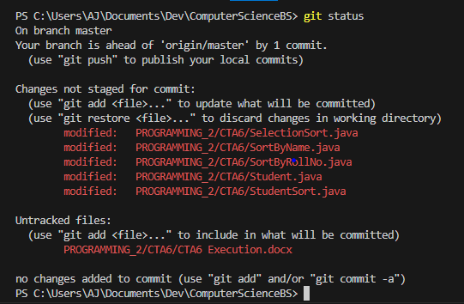

**Git Add & Status**

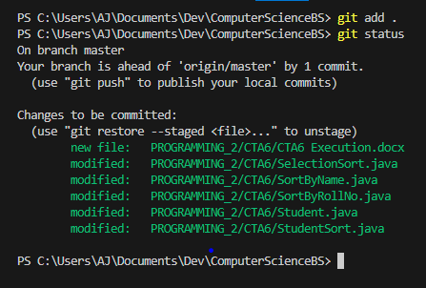

**Git Commit**

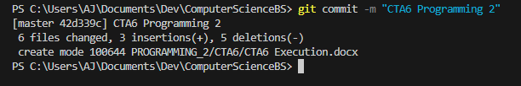

**Git Push Origin Master**

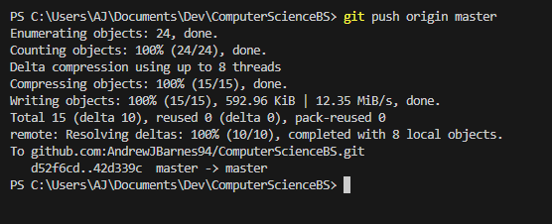

**Link To Repo & Screenshot**

[ComputerScienceBS/PROGRAMMING_2/CTA6 at master · AndrewJBarnes94/ComputerScienceBS (github.com)](https://github.com/AndrewJBarnes94/ComputerScienceBS/tree/master/PROGRAMMING_2/CTA6)

